**USE CASE DIAGRAM - Internhub**

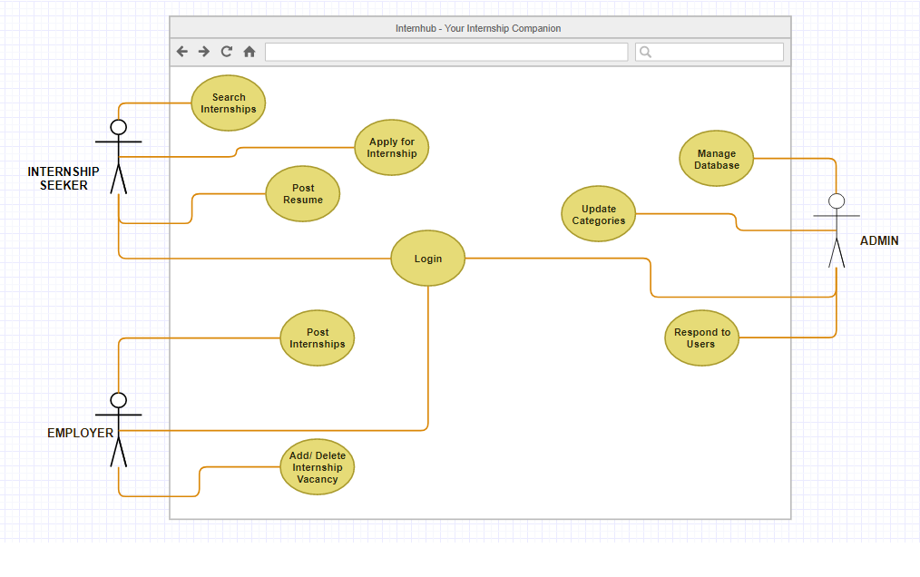

***fig : The above USE CASE diagram shows the relationship of Primary Actors of our Web Application and their Interaction in the form of use cases.***